Songs, Cheers, Poems

Songs
Students can write songs to define terms, describe formulas, and/or explain concepts. The following is the Quadratic Formula Song set to the tune of Twinkle, Twinkle, Little Star:
First you take a negative b
Then plus or minus and follow me
Under the big square root you’ll see
b² minus 4ac
Divide it all by two times a
That’s how you find the x today.

Students can work individually or in small groups. They can record or perform their songs. If the select a tune like Row, Row, Row Your Boat, the class can perform the song as a round.

Poems
As an alternative to songs and cheers, students may prefer to write poems. The Haiku, Cinquain, and Diamante Poetry are all types of poems that students may find of interest.

Haiku
This form of poetry has a simple formula:
- 3 lines
- 5 syllables in first line
- 7 syllables in second line
- 5 syllables in third line

Theme of calculus Beware integers
Find the slope of the tangent Negative times negative
dy / dx Is a positive

Interest equals Sine, cosine, tangent
Principal x Rate x Time Right triangle ratios
Simple interest Use SOH, CAH, TOA

Cinquain
This form of poetry tells about one idea, small detail, or experience. A cinquain has 5 lines. The lines can be arranged by words or by syllables. The cinquain has a pleasing rhythm but no regular rhythm or rhyme pattern. A cinquain can be capitalized and punctuated in any way or not at all.

Syllable Cinquain
Line 1 – title with 2 syllables
Line 2 – description of title with 4 syllables
Line 3 – action about the title with 6 syllables
Line 4 – feeling about the title with 8 syllables
Line 5 – synonym for title with 2 syllables

Square root Percent
Side length of square One hundred parts
Square root of 9 is 3 8% of 20
Perfect squares have easy square roots The answer is 1.6 – Wow!
Inverse Hundred

Word Cinquain
Line 1 – title with 1 word
Line 2 – description with 2 words
Line 3 – action with 3 words
Line 4 – feeling with 4 words
Line 5 – synonym with 1 word

Calculus Quadratic
Tangent slope Cup-shaped
Find function derivative Describes falling objects
Derivative equals zero – easy! Elegant curves, regular pattern
Limits Parabola

Diamante Poetry
This form of poetry makes a diamond shape:
Line 1 – noun
Line 2 – two adjectives
Line 3 – three action verbs that end in “-ing”
Line 4 – four nouns
Line 5 – three action verbs that end in “-ing”
Line 6 – two adjectives
Line 7 – noun

Hexagon
6-sided, regular
tiling, tessellating, connecting
triangles, trapezoids, rectangles, parallelograms
reflecting, rotating, translating
symmetrical, pleasing
Honeycomb

Lines
straight, infinite
slanting, pivoting, translating
slope, intercept, origin, equation
hypothesizing, investigating, measuring
horizontal, vertical
Relations

Cheers
As an alternative to songs, students may prefer to write a cheer with actions. The following is the BEDMAS cheer written by colleague Don Kemball:
Brackets!
Exponents!
Division!
Multiplication!
Addition!
Subtraction!
Doodle-dee-doo!

The photos below show the actions for each line of the cheer. The last line is accompanied by a little dance.

Brackets Exponents



Division Multiplication
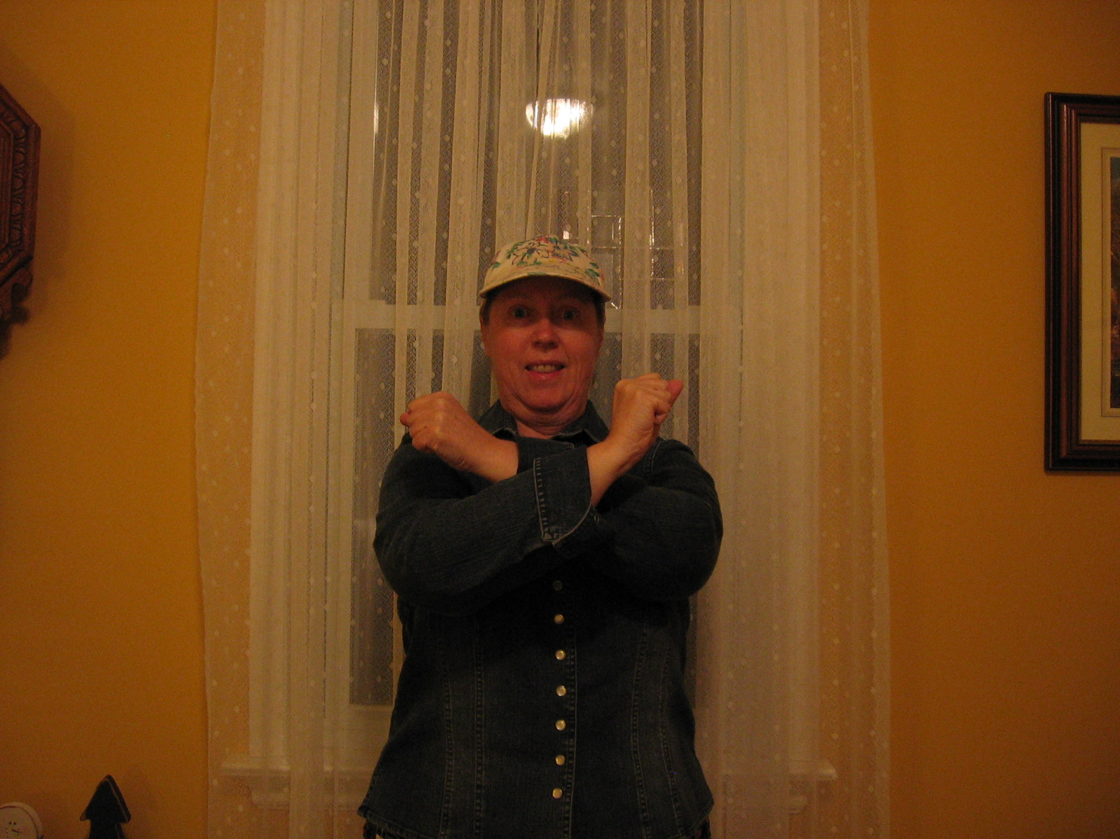


Addition Subtraction
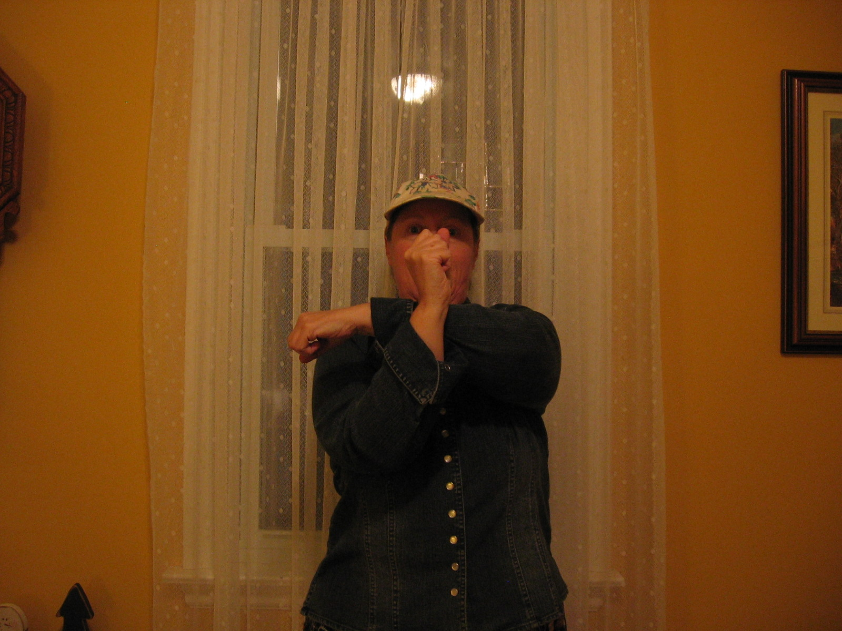
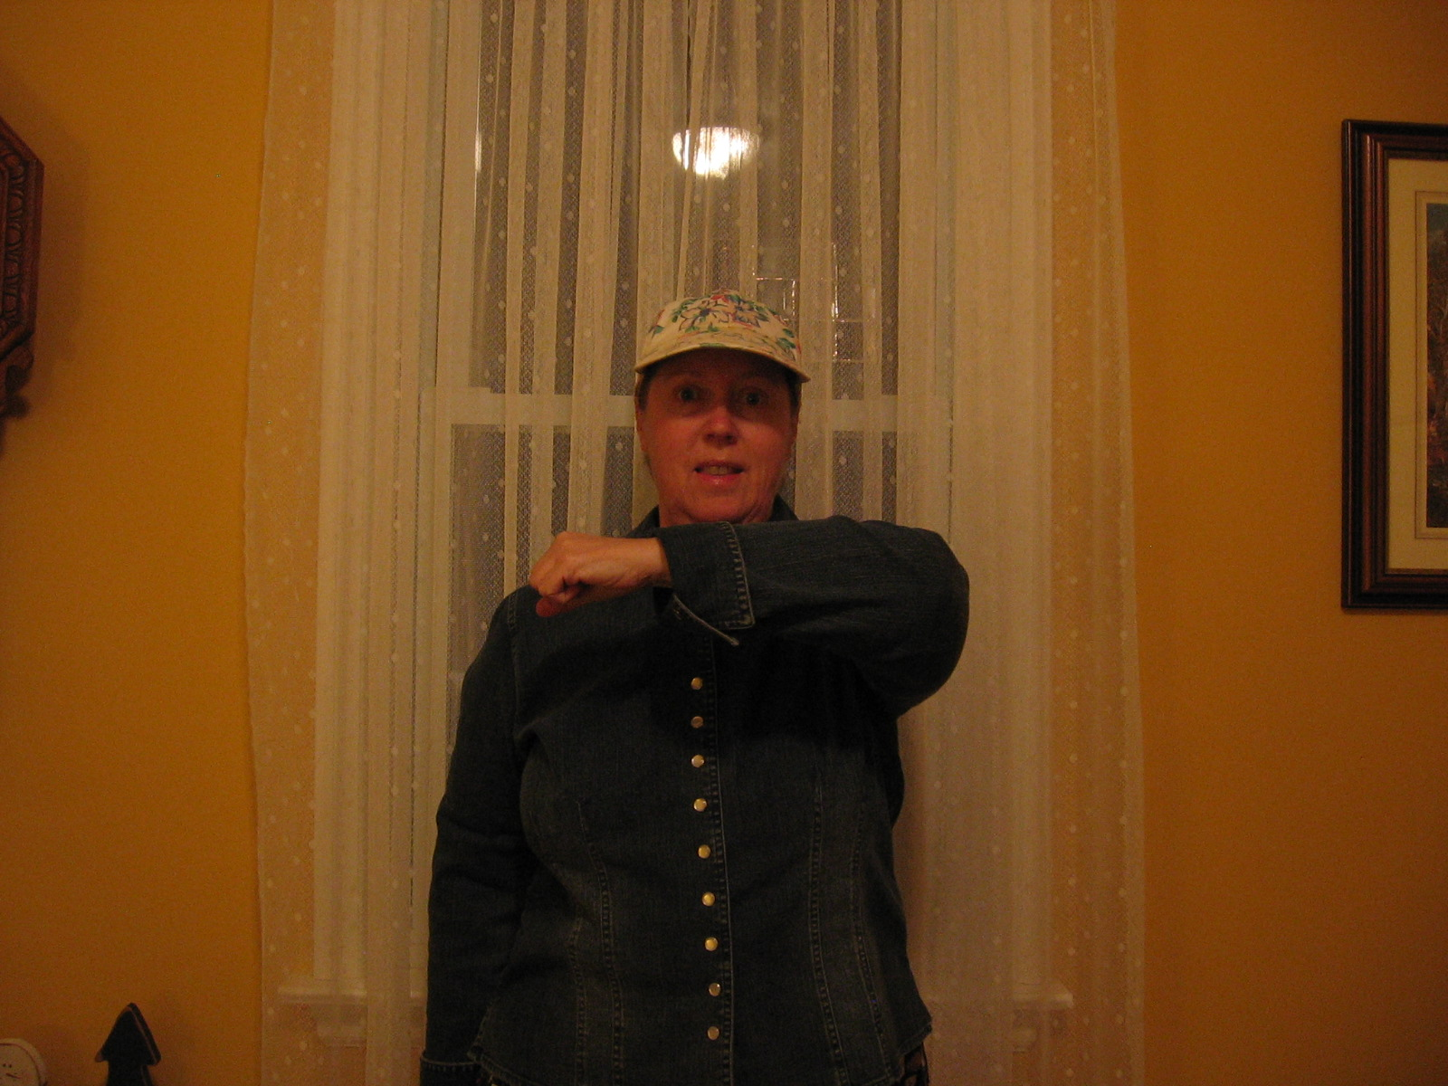

My colleague has the class chant the cheer faster and faster and then they do it as a round, group by group.

